
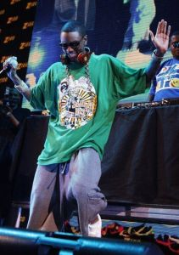
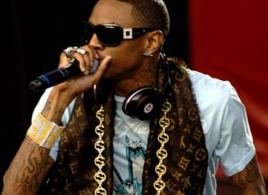

Presents SOULJA BOY
By the end of May 2007 "Crank That" receives its first air play and Soulja Boy meets with Mr. Collipark to sign a deal with Interscope Records. August 12, 2007, the song appears on the Emmy-award winning HBO series Entourage and by September 1st it has broken into the top 10 of the Billboard Hot 100 and tops the Billboard Hot RingMasters chart.
At age six, Way moved to Atlanta, Georgia, where he developed a love for rap music alongside his then partner Young Kwon, who taught him how to make repetitive beats and record himself saying the same thing over and over and introduced him to snap beats, according to Way. Right before he dropped out in 8th grade, he moved to Batesville, Mississippi with his father.
In November 2005 Soulja Boy, along with another rapper "Arab" posts his songs on the music-based social community SoundClick. Following positive reviews on SoundClick, Soulja Boy opens a YouTube account on January 13, 2006 so "... people can put your face to the things you spitting." The following month Soulja expanded onto MySpace to increase his fan base. A year later in March 2007 he would record "Crank That" and release his first independent album Unsigned and Sill Major. On April 11th a low budget video is filmed demonstrating the "Soulja Boy" dance.
Enjoy 99 more music channels
@ fantv.bgton.com
DeAndre Cortez Way (born July 28, 1990 in Chicago, Illinois), better known by his stage name Soulja Boy Tell 'Em, or simply Soulja Boy, is an American rapper. In September 2007, his single "Crank That (Soulja Boy)" reached number one on the Billboard Hot 100. He produced his whole album Souljaboytellem.com using just the demo version of FL Studio.

