
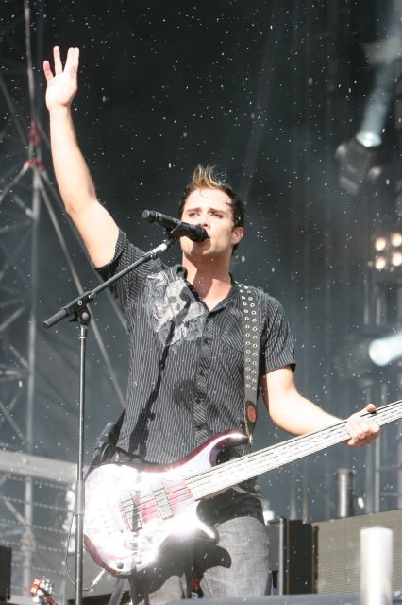
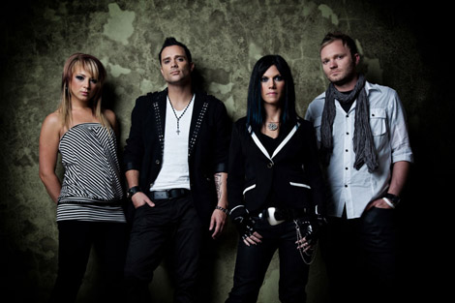
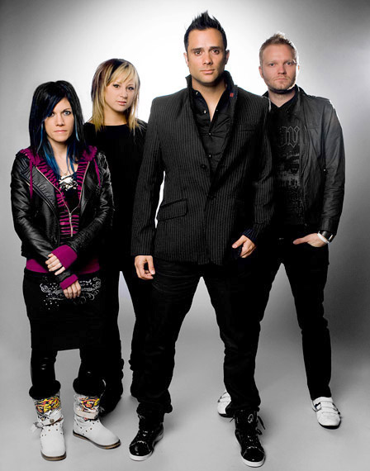
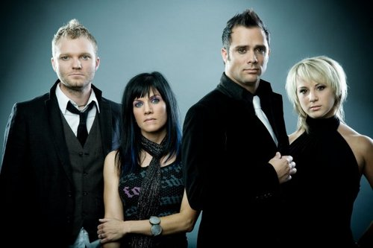
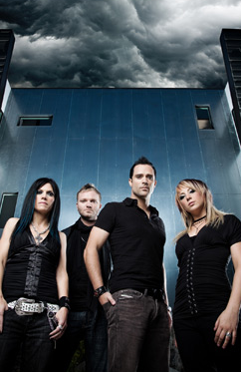
Presents SKILLET
Skillet is a Grammy-nominated Christian hard rock band originally formed in Memphis, Tennessee. The band consists of John Cooper (lead vocalist, bassist), his wife Korey Cooper (rhythm guitarist, keyboardist, vocalist), Ben Kasica (lead guitarist), and Jen Ledger (drummer, vocalist). Skillet has released eight albums, two receiving Grammy nominations: Collide and Comatose.. Over the past 13 years, Skillet has spanned many different genres, including hard rock, industrial rock, and symphonic rock. As of March 2010 they have sold 1.6 million albums worldwide.
The project follows Skillet’s 2004 Lava/Atlantic debut, Collide, which launched the group into the public eye with the single “Savior” (the #2 most added at CMJ’s “Loud Rock and Crucial Spins” panel the first week out), and garnered the quartet a prestigious Grammy Award nomination. Collide went on to become their third best-selling project to date, with over 200,000 units sold , while the band played some 200 dates a year - including tours with the likes of Saliva, Shinedown and Finger Eleven, Three Days Grace - in the process becoming one of the hardest working, heaviest rocking, and most broadly appealing acts of its generation
Skillet’s music is a mixture of hard rock, funk, punk,metal and industrial fused together with pure energy, and a strong love for the Lord, all thrown together in the pan! They formed as a group back in the early ‘90’s, and have produced many popular albums in their music ministry, much to the delight of their youthful fans, who not only get to enjoy fine hard rock music, with interesting sparkles of funk and punk, but also are encouraged, enlightened, fed with Christian messages about the Gospel, which point to Jesus.
Enjoy 99 more music channels
@ fantv.bgton.com

