
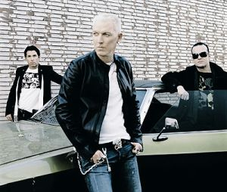
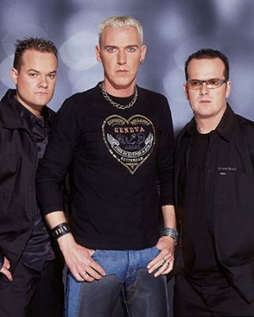

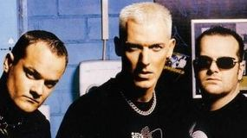
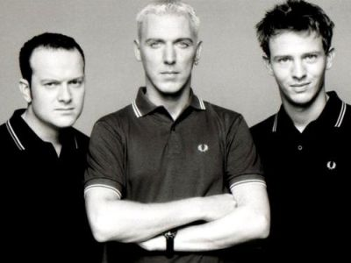
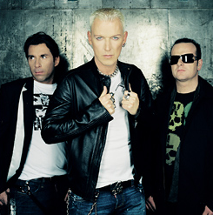

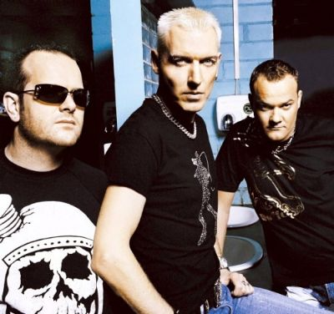
Presents SCOOTER
Scooter is a German group, formed by Soren Buehler, Hans-Peter Geerdes, Hendrik Stadler and Jens Thele, in Hamburg in 1994. Among their more well known hits are ‘Ramp! (The Logical Song)’, ‘Move Your Ass’, ‘Fire’, ‘How Much Is the Fish?’, ‘Nessaja’ and ‘Weekend!’.
At that point, Scooter officially became a group, and Geerdes’ rapping would become one of the band’s trademarks together with the fact that they all of their tracks are in fact remixes, though often with different titles than the original tracks.
Enjoy 99 more music channels
@ fantv.bgton.com
Originally the group started as a side project in 1994. Their debut single Vallée De Larmes (French for Valley Of Tears) reached #8 on the German dance chart. In April of that year, Scooter played their first live show in Hamburg, Germany, where vocalist Hans-Peter Geerdes began freestyling off the top of his head to an instrumental dance track.

