

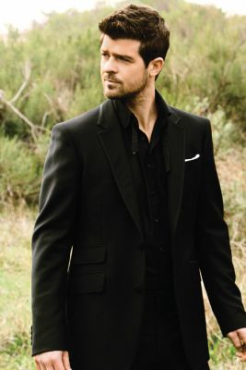
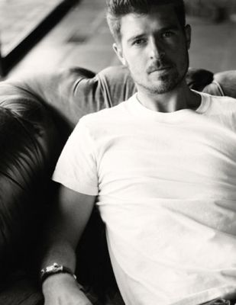

Presents ROBIN THICKE
Robin Charles Thicke (born March 10, 1977 in Los Angeles, California) is a Grammy award winning American R&B singer-songwriter, producer and actor signed to Pharrell’s Star Trak label. The son of actor Alan Thicke, he released his debut album, A Beautiful World, in 2003. He has gone on to release 2006’s The Evolution of Robin Thicke, 2008’s Something Else and his fourth studio album, Sex Therapy, was released in December of 2009. He is married to actress Paula Patton, and she gave birth to their first child, Julian Fuego, in April of 2010.
Before his days as a singer-songwriter, Thicke had written songs for 3T’s “Sexual Attention” (from 1995’s Brotherhood, which Thicke shares co-writing credit with one half of The Underdogs, Damon Thomas), Color Me Badd’s “Sexual Capacity” off the groups 1996 album, Now & Forever. Brownstone’s “Around You” (from 1997’s Still Climbing) and collaborated with Jordan Knight, Jimmy Jam and Terry Lewis on several songs in Knight’s 1999 album Jordan Knight.
In 2000 Thicke went to work on material for his debut album, initially entitled Cherry Blue Skies. The album focused more on blue-eyed soul, than his pop-offerings for other artists. Mixing in influences from British funk outfit Jamiroquai and sounding like his blue-eyed contemporary, Canadian neo-soul singer, Remy Shand, the album was tipped for huge things and to be released in the fall of 2002.
Enjoy 99 more music channels
@ fantv.bgton.com

