
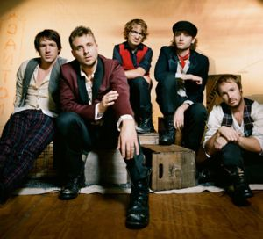
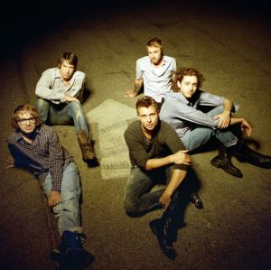

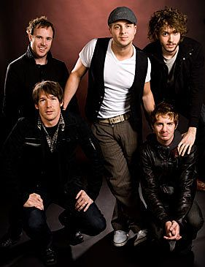
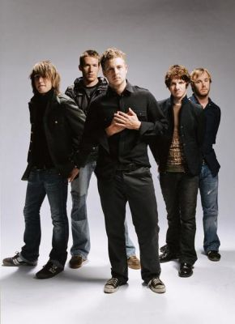
Presents ONEREPUBLIC
OneRepublic is an American, self-proclaimed “genreless”, band formed in Colorado Springs in 2002 by Ryan Tedder and Zach Filkins. After a few years of moderate success, they have since drawn mainstream attention with the release of their single “Apologize,” which has sold in excess of 7 million singles worldwide. The song, according to SoundScan Data, is one of only two songs that have reached 3 million legal downloads in history. A remix of “Apologize” was featured on Timbaland’s Shock Value and the band’s debut album, Dreaming Out Loud, produced by Greg Wells.
Their debut album was released in the United States on November 20, 2007, with international release dates staggered throughout early 2008. As of June 14, 2008, Dreaming Out Loud had sold 761,298 copies in the U.S. with the bands total album sales coming to over 1.5 million worldwide so far. The band’s second single, “Stop and Stare,” has also crossed the 2 million mark in terms of worldwide single sales. Their third single, “Say (All I Need)”, has been released in the UK and in the U.S.
OneRepublic’s song “Apologize”, written by Ryan Tedder, was released in its original version on the band’s debut album Dreaming Out Loud. The song was also prominently featured as a remix on Timbaland’s 2007 release of Shock Value. The single, as featured on Shock Value, has gone 3x Platinum (marking three million copies sold in the U.S) and 5 million copies worldwide. It peaked at number three on the U.K. Official Top 40 Week on November 11, 2007. The week of November 10, 2007, “Apologize” was the biggest radio airplay hit in the history of Top 40 radio in North America, racking up an astounding 10,331 spins in one week.
Enjoy 99 more music channels
@ fantv.bgton.com

