

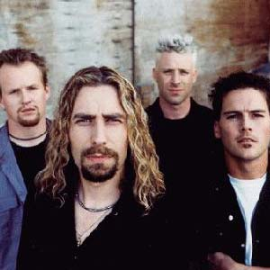
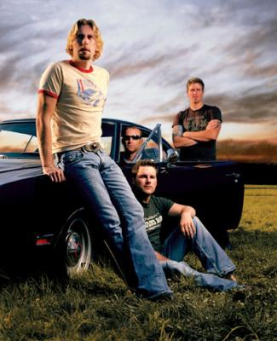

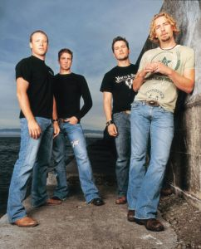
Presents NICKELBACK
In December 2009, Nickelback were ranked 7th on Billboard Magazine's list of "Artists of the Decade" - both the highest-ranked band and the highest-ranked rock artist in the list.
Nickelback is a Canadian rock band from Hanna, Alberta, formed in 1995 by Chad Kroeger, Mike Kroeger, Ryan Peake and then-drummer Brandon Kroeger. While largely a rock band, the group has also experimented with various other musical styles such as pop and country, aside from their hard rock and post-grunge base.
Nickelback is one of the most commercially successful Canadian groups, having sold 30 million records worldwide. Nickelback ranks as the 11th best selling music act of the 2000s, and is the 2nd best selling foreign act in the US behind The Beatles for the 2000s.
Enjoy 99 more music channels
@ fantv.bgton.com
Billboard Magazine also named Nickelback as the Adult Pop Artist of the decade. The band has sold 21,000,000 album copies in the U.S.

