
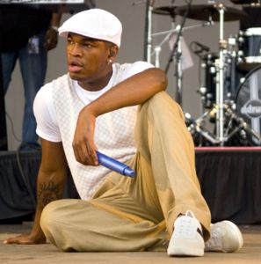
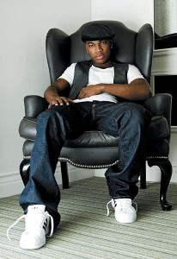
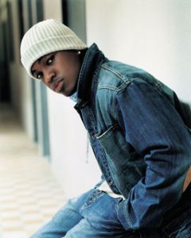
Presents NE-YO
Def Jam released "Stay", featuring Peedi Crakk, as Ne-Yo's debut single in 2005, and Ne-Yo's debut album In My Own Words, Ne-Yo's debut album was released in February 2006. "Stay" was well-received by the urban community, reaching number 36 on the Hot R&B/Hip-Hop Singles & Tracks, but failed to chart on the Billboard Hot 100. The album's second single, "So Sick", was a larger success, reaching number-one on the Hot 100 and the Pop 100, as well as the official UK chart.
Shaffer Chimere Smith (born on October 18, 1982 in Camden, Arkansas but raised in Las Vegas, Nevada) is an American R&B singer-songwriter. He is best known by his stage name, Ne-Yo. He is currently signed to Def Jam Records. He was previously best known for co-writing Mario's 2004 number one hit, "Let Me Love You", before he began a recording career of his own in 2005. Ne-Yo's debut album, In My Own Words, was released in early 2006 and debuted at number one on The Billboard 200 selling 301,000 copies in the first week. During the same period, Ne-Yo's second single, "So Sick", (produced by Stargate) became the number one song on the Billboard Hot 100 chart. He is of African-American, Puerto Rican, and Chinese descent.
While still in high school, Ne-Yo belonged to R&B group Envy, going by the stage-name GoGo. Since the group's disbanding in 2000, Ne-Yo had substantive success as a songwriter, co-authoring songs for artists such as Mary J. Blige, Ruben Studdard, Marques Houston, Faith Evans, Christina Milian, B2K, Nivea, Tyrese, Rihanna, Jamie Foxx and Heather Headley. After getting out of a record deal with Columbia Records that saw no released material, Ne-Yo decided to remain as a songwriter, but a close friend introduced him to L.A. Reid, who signed Ne-Yo on the spot to Def Jam Records.
Enjoy 99 more music channels
@ fantv.bgton.com
The singer's nickname was given to him by a friend (Shawn Milligan), who stated that the singer could 'see' music like Keanu Reeves's "Neo" character could see the Matrix in The Matrix film trilogy. Ne-Yo added the "-Yo" to match rap culture. In the May Vibe Magazine it states that Ne-Yo has a Chinese grandfather. Ne-Yo said that growing up his father 'Wiley' would abuse his mother. The singer also has a son named Chimere.

