
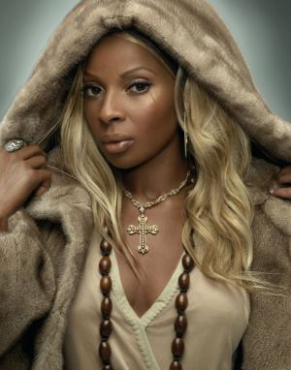


Presents MARY J. BLIGE
Mary Jane Blige (born January 11, 1971), also known as Mary J. Blige, is an American singer, producer, songwriter, actress, and rapper. A recipient of nine Grammy Awards and many other honors, Blige has recorded eight multi-platinum albums. Blige has received the World Music Legends Award for combining hip hop and soul in the early 1990s. She was named one of the 100 greatest singers of all time by Rolling Stone magazine. As of 2010, Blige has sold over 50 million records worldwide.Blige has cited Anita Baker, Chaka Khan and Aretha Franklin as influences.
When her debut album, What's the 411?, hit the street in 1992, critics and fans alike were floored by its powerful combination of modern R&B with an edgy rap sound that glanced off of the pain and grit of Mary J. Blige's Yonkers, NY, childhood. Called alternately the new Chaka Khan or new Aretha Franklin, Blige had little in common stylistically with either of those artists, but like them, she helped adorn soul music with new textures and flavors that inspired a whole generation of musicians.
With her blonde hair, self-preserving slouch, and combat boots, Blige was street-tough and beautiful all at once, and the record company execs who profited off of her early releases did little to dispel the bad-girl image that she earned as she stumbled through the dizzying first days of her career. As she exorcised her personal demons and softened her style to include sleek designer clothes, she remained a hero to thousands of girls growing up in the same kinds of rough places she came from.
Blige reinvented her career again and again by shedding the bad habits and bad influences that kept her down; by the time her fourth album, Mary, was released in 1999, she had matured into an expressive singer able to put the full power of her voice behind her music, while still reflecting a strong urban style. With her fifth album, No More Drama, it wasn't just Blige's style that shone through the structures set up for her by songwriters and producers, it was her own vision -- spiritual, emotional, personal, and full of wisdom, it reflected an artist who was comfortable with who she was and how far she had come.
Enjoy 99 more music channels
@ fantv.bgton.com

