

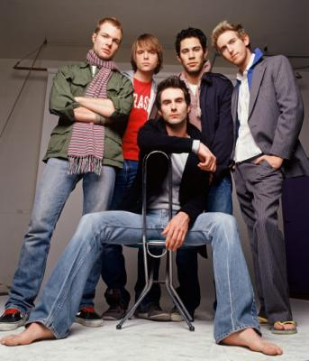
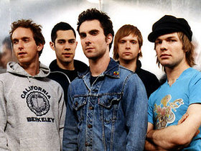
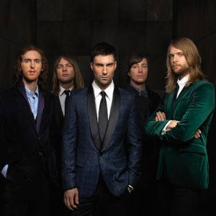


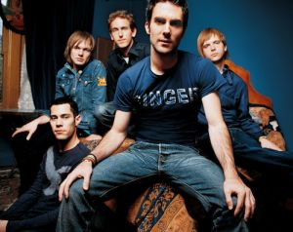
Presents MAROON 5
Maroon 5 is a Grammy Award-winning American pop rock band. Formed in Los Angeles, United States, the group comprises five members: Adam Levine (lead vocals, rhythm guitar), James Valentine (lead guitar, backing vocals), Jesse Carmichael (keyboards, rhythm guitar, backing vocals), Mickey Madden (bass guitar), and Matt Flynn (drums, percussion).
After a hiatus from the music scene, Maroon 5 released their second studio album, It Won’t Be Soon Before Long in May 2007, five years after Songs About Jane. The second set debuted at #1 on the Billboard 200 with first week sales of nearly half a million. The album has since gone on to become platinum with 1.8 million albums sold in the United States alone and over 3.5 million world wide. The band performed throughout the summer and fall of 2007, including a North American tour with The Hives. They followed that with a world tour with New Found Glory. Beginning March 28, 2008, they will tour with Counting Crows and Sara Bareilles.
Enjoy 99 more music channels
@ fantv.bgton.com
Maroon 5 has won several awards for its debut album Songs About Jane. Released in June 2002, the album enjoyed major chart success, going gold, platinum, and triple platinum in many countries around the world. In support of Songs About Jane, Maroon 5 toured extensively throughout 2003 – 2005, in which a live album was released, entitled Live - Friday the 13th. Original member Ryan Dusick left the band in September 2006, due to injuries sustained by the constant touring, and was replaced by Matt Flynn.

