
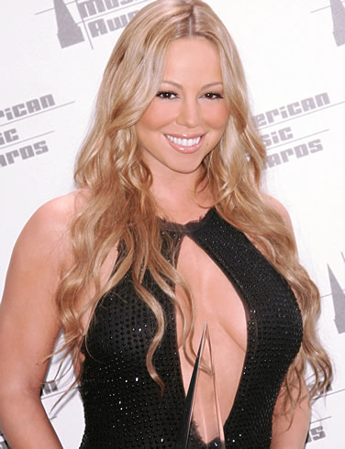
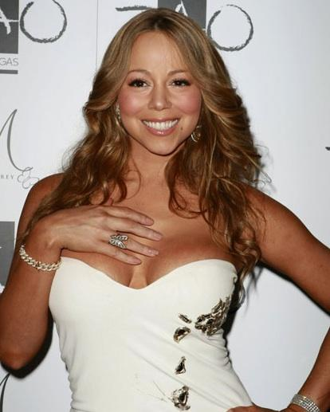

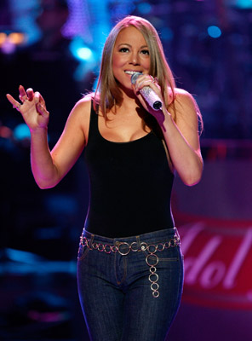
Presents MARIAH CAREY
He has had 6 Grammy In 2008, Carey earned her eighteenth number one single on the Hot 100, the most for any solo artist. Aside from her commercial accomplishments, she has earned five Grammy Awards and is known for her five-octave vocal range, power, melismatic style and use of the whistle register.
Mariah Carey (born March 27, 1970) is an American R&B, pop and hip hop singer, songwriter, record producer and actress. She made her recording debut in 1990 under the guidance of Columbia Records executive Tommy Mottola, and became the first recording artist to have her first five singles top the U.S. Billboard Hot 100 chart. Following her marriage to Mottola in 1993, a series of hit records established her position as Columbia's highest-selling act. According to Billboard magazine, she was the most successful artist of the 1990s in the United States.
Following her separation from Mottola in 1997, Carey introduced elements of hip hop into her album work, to much initial success, but her popularity was in decline when she left Columbia in 2001. She signed to Virgin Records but was dropped from the label and bought out of her contract the following year after a highly publicized physical and emotional breakdown, as well as the poor reception given to Glitter, her film and soundtrack project. In 2002, Carey signed with Island Records, and after a relatively unsuccessful period, she returned to the top of pop music in 2005 with her album, The Emancipation of Mimi.
Enjoy 99 more music channels
@ fantv.bgton.com
According to Island Def Jam, Carey has sold more than 175 million albums, singles and videos worldwide, making her one of the world's best-selling music artists. She was named the best-selling female pop artist of the millennium at the 2000 World Music Awards and is also a recipient of the Chopard Diamond Award in 2003, recognizing sales of over 100 million albums worldwide. According to the Recording Industry Association of America (RIAA), she is the third-best-selling female artist and seventeenth overall recording artist with shipments of 63 million albums in the US.

