
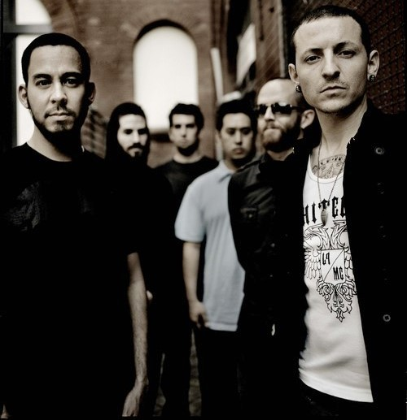
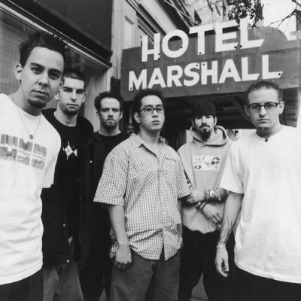
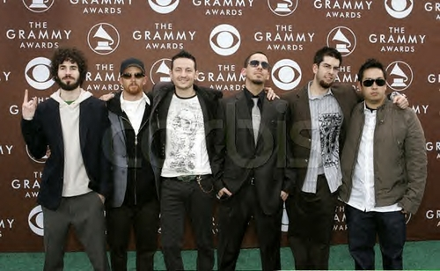
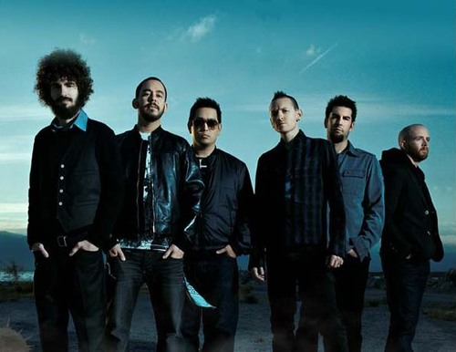
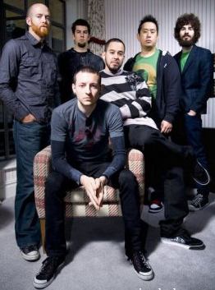
Presents LINKIN PARK
Linkin Park is a band from Agoura Hills, California. The band consists of Joe “Mr. Hahn” Hahn, Mike Shinoda, Dave Farrell (a.k.a. Phoenix), Chester Bennington, Brad Delson and Rob Bourdon. The band’s first full studio album, Hybrid Theory, released in 2001, had a huge success, selling 42 million copies worldwide as of October 2009.
Among its singles were One Step Closer, Crawling, and the band’s highest-selling single, In the End. In 2001, the band released “Frat party at the pancake festival”. A dvd with live stuff, extra footage of the band and the music video’s from Hybrid Theory. A remix album, Reanimation was released in 2002, and was based around Hybrid Theory songs.

Released under the band name “Hybrid Theory”, the band’s first album, Hybrid Theory EP was released in 1995. Only 1000 copies of this very rare original EP were made.
The band’s second studio album, Meteora (released 2003), was not so successful as “Hybrid Theory”. Still, it sold 10 million copies worldwide, spawned the worldwide hit Breaking the Habit, and was the first Linkin Park album that was not fully rap driven. A limited edition live album and DVD came next: Live in Texas. It was an opportunity for fans who have not been to the band’s gigs to see their performance live.
Enjoy 99 more music channels
@ fantv.bgton.com

