

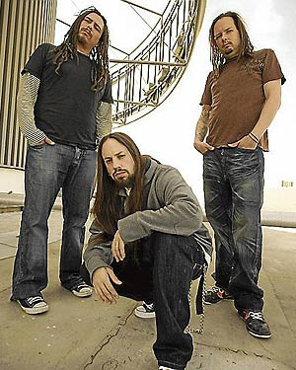



Presents KORN
Korn is an American metal band formed in Bakersfield, California, in early 1993. The current band line up includes four members: Jonathan Davis, James "Munky" Shaffer, Reginald "Fieldy" Arvizu, and Ray Luzier. The band was formed after the disbandment of L.A.P.D..
Korn formed in 1993, the same year they released their first demo album, Neidermeyer's Mind. The album featured the two ex-members of Korn, Brian "Head" Welch and David Silveria. Their debut album, Korn was released in 1994, where they featured the same musicians that had performed on Neidermeyer's Mind. The band began recording Life Is Peachy in April 1996, and released it on October 15, 1996. Follow the Leader is recognized as Korn's mainstream breakthrough, peaking #1 on the Billboard 200 in 1998, along with the following album, Issues in 1999. The band released Untouchables on June 11, 2002, and later released Take a Look in the Mirror November 21, 2003, both peaking in the top 10 of the Billboard 200.
Their first compilation album, Greatest Hits Vol. 1, peaked #4 on the Billboard 200. See You on the Other Side was released on December 6, 2005, and Korn's untitled album was released nearly 2 years later on July 31, 2007, Korn III: Remember Who You Are, the bands ninth studio album which was released July 13, 2010 via Roadrunner Records. Korn currently has 35 singles and 18 of which have charted. The band has had 6 video albums and 32 music videos.
Enjoy 99 more music channels
@ fantv.bgton.com
To date, Korn has sold 25 million albums in the U.S., and selling 35 million albums worldwide as of 2009. while earning six Grammy nominations—two of which they have won (for "Freak on a Leash" and "Here to Stay").

