
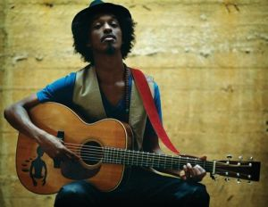
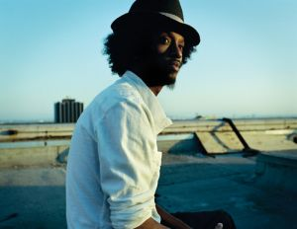
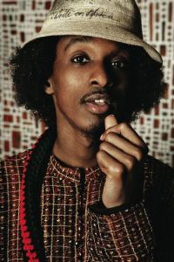
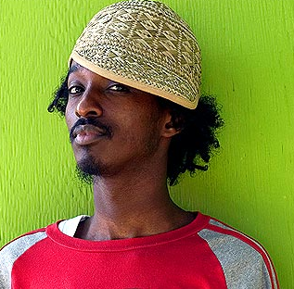
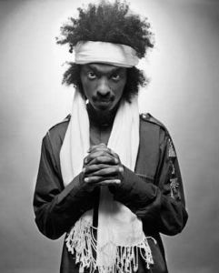
Presents K'NAAN
K’naan participated in the Breedlove Odyssey Tour with Mos Def, Talib Kweli, Pharoahe Monch and Jean Grae. He also participated in the “Welcome To Jamrock” tour along with Damian Marley. The Dusty Foot Philosopher received a 2006 Juno Award for Rap Recording of the Year, and was nominated for the inaugural Polaris Music Prize. He also featured in a song by M1, titled “Till We Get There”.
K’naan (Keinaan, meaning traveller in Somali, born 1978) is a Somali-Canadian poet and hip-hop artist. Born in Mogadishu, at age 13 he left for New York City with his mother and brother and finally settled in the Rexdale neighbourhood of Toronto.
In 2001 K’naan performed in Geneva at the 50th anniversary of the United Nations High Commissioner for Refugees. In 2005, he performed with DobaCaracol during the Live 8 concert in Barrie, Ontario. His full-length debut album, The Dusty Foot Philosopher, was released in 2005. His song “Soobax” (pronounced “So-Bah”) is now featured in the best selling video game FIFA Football 2006, made by Electronic Arts and he has toured the world with the cup.
Enjoy 99 more music channels
@ fantv.bgton.com
The song “In the Beginning” from the album The Dusty Foot Philosopher was featured in the 2008 Comedy “Harold and Kumar Escape from Guantanamo Bay”. He also toured with Stephen Marley on Stephen’s “Mind Control” tour.

His latest album “Troubadour” was released in 2009 featuring guests artists such as Damian Marley, Adam Levine, Kirk Hammett, Mos Def, and Chali 2NA.

