
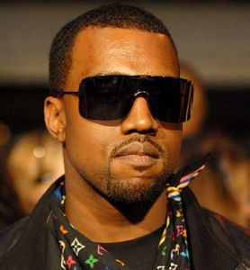

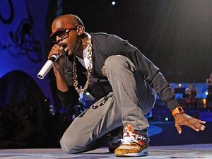
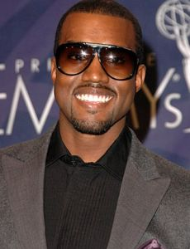
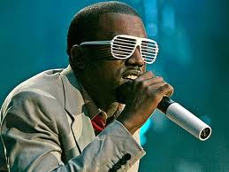
Presents KANYE WEST
Kanye Omari West (born June 8, 1977) is an American rapper, singer, and record producer. West first rose to fame as a producer for Roc-A-Fella Records, where he eventually achieved recognition for his work on Jay-Z's album The Blueprint, as well as hit singles for musical artists including Alicia Keys, Ludacris, and Janet Jackson.
His style of production originally used pitched-up vocal samples from soul songs incorporated with his own drums and instruments. However, subsequent productions saw him broadening his musical palette and expressing influences encompassing '70s R&B, baroque pop, trip hop, arena rock, folk, alternative, electronica, synth-pop, and classical music.
West released his debut album The College Dropout in 2004, his second album Late Registration in 2005, his third album Graduation in 2007, and his fourth album 808s & Heartbreak in 2008. His four albums have received numerous awards, including a cumulative twelve Grammys, and critical acclaim. All have been very commercially successful, with 808s & Heartbreak becoming his third consecutive #1 album in the U.S. upon release.
West also runs his own record label GOOD Music, home to artists such John Legend, Common and Kid Cudi. West's mascot and trademark is "Dropout Bear," a teddy bear which has appeared on the covers of four of his five albums as well as various single covers and music videos. About.com ranked Kanye West #8 on their "Top 50 Hip-Hop Producers" list. On May 16, 2008, Kanye West was crowned by MTV as the year's #1 "Hottest MC in the Game."
Enjoy 99 more music channels
@ fantv.bgton.com

