


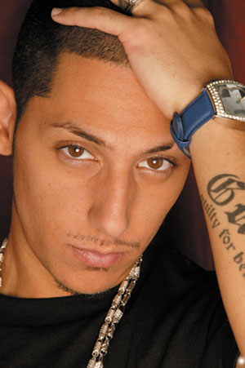



Presents K-MARO
Cyril Kamar (born January 31, 1980 in Beirut, Lebanon) better known by his stage name K.Maro, sometimes also K'Maro is a Canadian Pop singer-songwriter and producer of Lebanese origin. He sings in French and in English.
He is also founder / owner and CEO of K.Pone.Inc Music Group, an entertainment company and K.Pone.Inc record label, with signing of a host of well-known artists. In 2002, K.Maro released an album entitled "I am à l'ancienne" only in Canada. K.Maro released his official solo debut album La Good Life in the mid 2004, with 3 singles released from it. He also released his second studio album, Million Dollar Boy, in late 2005.
In 2006 he released his first remix album - 10th Anniversary: Platinum Remixes. His third studio album entitled Perfect Stranger was released on October 24, 2008. A new album is due for release on the 27th of April 2010 entitled 01.10.
Enjoy 99 more music channels
@ fantv.bgton.com

