





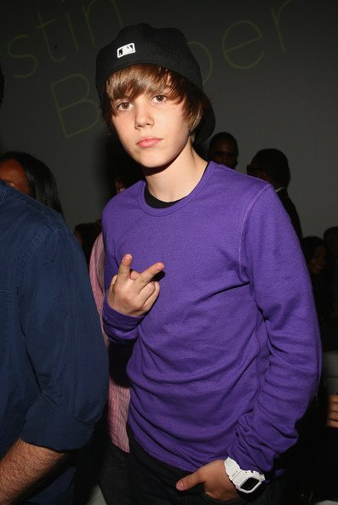
Presents JUSTIN BIEBER
While searching for videos of a different singer, Scooter Braun, a former marketing executive of So So Def, clicked on one of Bieber's 2007 videos by accident. Impressed, Braun tracked down the theater Bieber was performing in, located Bieber's school, and finally contacted Mallette. Mallette was reluctant; she remembered praying, "God, I gave him to you. You could send me a Christian man, a Christian label!" However, after praying with her church elders and receiving their encouragement, she permitted Braun to fly Bieber, then 13, to Atlanta, Georgia, to record demo tapes. A week after arriving, Bieber sang for R&B singer/songwriter Usher. Bieber was soon signed to Raymond Braun Media Group (RBMG), a joint venture between Braun and Usher,
Bieber's debut single, "One Time", was released worldwide in 2009, and charted in the top 30 in more than 10 countries. His debut EP, My World, released on November 17, 2009, was certified platinum in the United States, giving Bieber the year's highest debut. Seven songs from the album charted on the Billboard Hot 100, a first for a debut. In January 2010, his song "Baby" was released and became an international hit.
His first full studio release, My World 2.0 was released on March 23, 2010; it debuted at No. 1 in the United States and within the top 10 of several countries; it was certified platinum less than two months after its U.S. release.
Enjoy 99 more music channels
@ fantv.bgton.com
Justin Drew Bieber (born March 1, 1994) is a Canadian pop-R&B singer. Bieber was discovered in 2008 by Scooter Braun, who happened across Bieber's videos on YouTube and later became his manager.

