
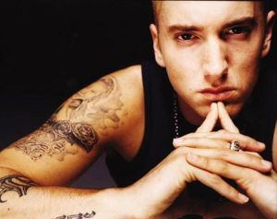
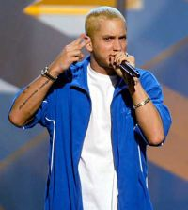

Presents EMINEM
Eminem released his first album since 2004's Encore, titled Relapse, on May 15, 2009. He is the best-selling artist of the decade on the US Nielsen SoundScan, and has sold more than 80 million albums worldwide to date, making him one of the best-selling music artists in the world.Eminem was ranked 82nd on Rolling Stone magazine's list of the 100 Greatest Artists of All-Time. Eminem was also named the Best Rapper Ever by Vibe magazine. Including his work with D12, Eminem has achieved nine No. 1 albums on the Billboard Top 200, 7 solo and 2 with D12.[citation needed] He has had 13 number one singles worldwide. In December 2009 Eminem was named the Artist of the Decade by Billboard magazine.
Marshall Bruce Mathers III (born October 17, 1972), better known by his stage name Eminem, is an American rapper, record producer and actor. Eminem quickly gained popularity in 1999 with his major-label debut album, The Slim Shady LP, which won a Grammy Award for Best Rap Album. The following album, The Marshall Mathers LP, became the fastest-selling solo album in United States history. It brought Eminem increased popularity, including his own record label, Shady Records, and brought his group project, D12, to mainstream recognition.
The Marshall Mathers LP and his third album, The Eminem Show, also won Grammy Awards, making Eminem the first artist to win Best Rap Album for three consecutive LPs. He then won the award again in 2010 for his album Relapse, giving him a total of 11 Grammys in his career. In 2002, he won the Academy Award for Best Original Song for "Lose Yourself" from the film, 8 Mile, in which he also played the lead. "Lose Yourself" would go on to become the longest running No. 1 hip-hop single. Eminem then went on hiatus after touring in 2005.
Enjoy 99 more music channels
@ fantv.bgton.com
His albums The Eminem Show, The Marshall Mathers LP, and Encore (in order) ranked as the 3rd, 7th, and 40th best album of the 2000-2009 decade by Billboard magazine. According to Billboard, Eminem has two of his albums among the top five highest selling albums of the 2000s. In the UK, Eminem has sold over 12.5 million records.

