

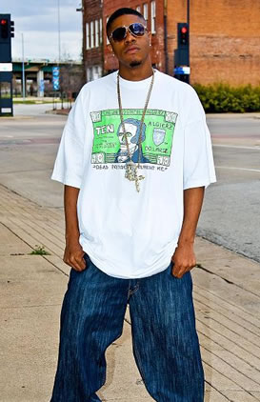
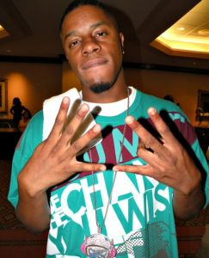

Presents DORROUGH
After the huge success of the release of second single hit, "Ice Cream Paint Job" there were two remixes to follow. On August 11, 2009, the first "Ice Cream Paint Job" (Remix) which featured artists such as Soulja Boy, Jermaine Dupri, Jim Jones, Slim Thug, E-40 & Rich Boy. To diversify the two remixes, people believed calling the first remix "Down South". But this never went into effect once the first remix was released. A few months following the first remix release, the second "Ice Cream Paint Job" (West Coast Remix)was released on September 22, 2009.
Dorwin Demarcus Dorrough, better know by his stage name Dorrough, is an American rapper. Dorrough was born and raised in Dallas, Texas. He attended Lancaster High School in Lancaster, Texas, where he was captain of the basketball team. He attends Prairie View A&M University. Dorrough started his musical career giving out mixtapes at basketball games at his high school.
His first single, "Walk That Walk," reached #28 on the Hot R&B/Hip-Hop Songs chart and #12 on the Hot Rap Tracks chart. His second single, "Ice Cream Paint Job," was his first to reach the Billboard Hot 100, reaching #27. His debut album, Dorrough Music, was released on E1 Music August 4, 2009 and the album peaked at #36 on the Billboard 200, #6 on the Top R&B/Hip-Hop Albums, and #2 on the Top Rap Albums.
Enjoy 99 more music channels
@ fantv.bgton.com

