
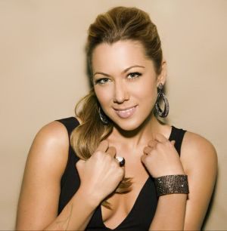
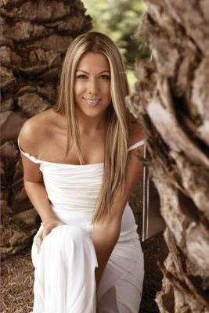

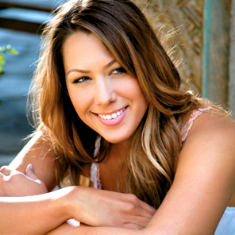
Presents COLBIE CAILLAT
Los Angeles vocalist Colbie Caillat is a singer-songwriter with songs based on a humble approach; although her music is acoustic, the arrangements go much deeper, culling from classical folk, jazz, and pop.
At the age of fifteen something happened to Colbie that would change her life completely - she met Michael Blue, a producer and engineer located in Westlake Village, Ca. At the time, Michael, having worked with artists such as Augustana, Five for Fighting, and Carrie Underwood, was working on Runway music for St. John Knit’s seasonal clothing lines. To cut a long story short, Michael took Colbie under his wing and began to use her voice on the tracks he was producing. Within the first season he knew she was something amazing and started producing and collaborating on additional songs with Colbie. Then, at the age of 19, Colbie wrote her first song on the guitar, and she has never stopped since.
Caillat, who was born in California (May 28, 1985), grew up in Malibu and other cities in Ventura County. As a child, she was surrounded by music. Her father, Ken Caillat, is most notably remembered for Co-Production and Engineer credits on Fleetwood Mac’s “Rumours,” among others. Every sound of Colbie’s soulful style unfolds a story of her many travels through life.
Enjoy 99 more music channels
@ fantv.bgton.com
Colbie started her singing debut at an early age (11) with special performances around her house. Within weeks she ventured out to talent shows and school performances. Her parents, who would call her “little bird,” would wake up in the early morning to find her singing her heart out. With the help of her parents, she was charmed into the idea that she had singing potential and began lessons with a vocal coach.

