

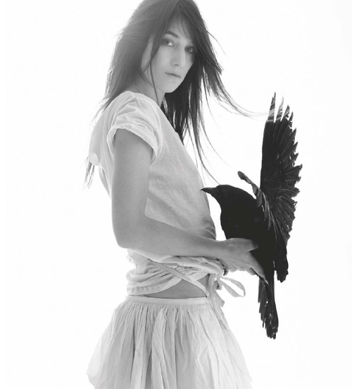

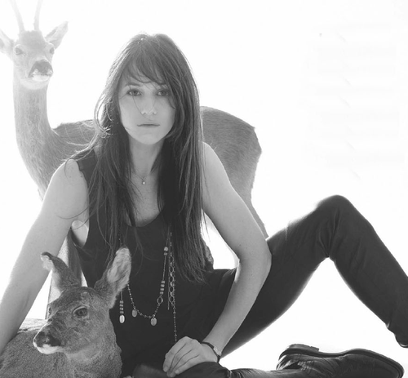

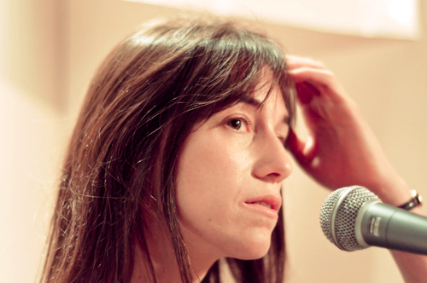
Presents CHARLOTTE GAINBOURG
Charlotte Gainsbourg (born 21 July 1971 as Charlotte Lucy Gainsburg) is a French actress and singer-songwriter.
Gainsbourg was born in London, but was raised in Paris. She is the daughter of British actress and singer Jane Birkin and French actor/singer Serge Gainsbourg. Her maternal grandmother was actress Judy Campbell and her uncle is the screenwriter Andrew Birkin, who directed her in The Cement Garden. Gainsbourg’s longtime partner and spouse is the French actor/director Yvan Attal, with whom she has two children, Ben (born on 12 June 1997) and Alice (born on 8 November 2002).
Gainsbourg made her motion picture debut playing Catherine Deneuve’s daughter in the film Paroles et musique (1984). In 1986, Gainsbourg won a César Award for “Most Promising Actress” for L’effrontée, and, in 2000, she won “Best Supporting Actress” for the film La Bûche.
Gainsbourg made her musical debut with her father on the song “Lemon Incest” in 1984. Two years later, she released her debut album Charlotte for Ever, which was produced by her father. In 2007, Gainsbourg appeared alongside Gael Garcia Bernal in Michel Gondry’s La Science des rêves and as Claire in the Todd Haynes directed Bob Dylan biopic I’m Not There, also contributing a cover of the Dylan song “Just Like a Woman” to the film’s soundtrack.
Enjoy 99 more music channels
@ fantv.bgton.com

