
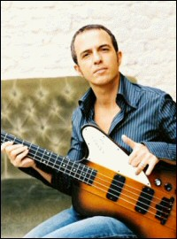
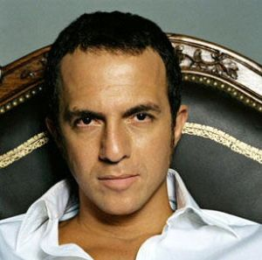
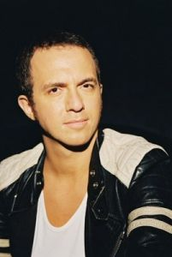
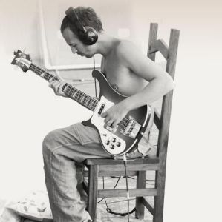
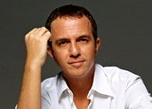
Presents CALOGERO
Calogero (born Calogero Maurici on July 30, 1971 in Échirolles, near Grenoble) is a French singer. By the age of six Calogero had already taken an interest in music. He quickly learned to play several instruments, including the flute, piano and bass, and in 1986 became the lead singer and song-writer for the band Charts.
He started it together with his brother, Gioacchino, and a childhood friend, Francis Maggiulli. Between 1989 and 1997, “Charts” released 5 albums : “L’océan sans fond” (1989), “Notre monde à nous” (1991), “Hannibal” (1994), “Acte 1” (1995), and “Changer” (1997). As the band began to lose its momentum, Calogero decided to launch himself as a solo artist and gathered important connections by writing songs and collaborating with already popular artists, such as Zazie and Pascal Obispo.
The latter helped produce Calogero’s first solo album Au milieu des autres (2000). His second album, Calogero (2002) was a huge success with the hit singles “En apesanteur”, “Aussi libre que moi”, “Tien an men” and “Prendre racine”. Finally, in 2004, Calogero released .calog3ro, containing “Face à la mer”, a duet with French rapper Passi, and several other top singles such as “Yalla” and “Si seulement je pouvais lui manquer”.Calogero’s moving lyrics and frail, tender voice have made him one of France’s top pop/rock singers.
Enjoy 99 more music channels
@ fantv.bgton.com

