
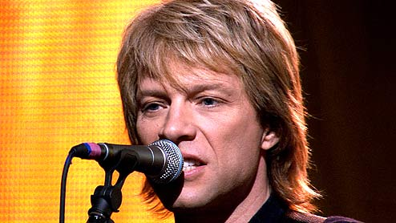
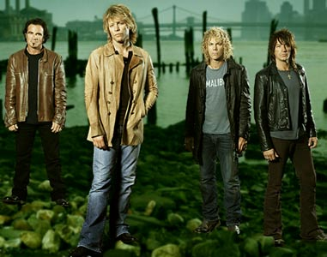
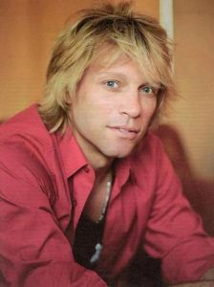
Presents BON JOVI
Throughout their career, the band have released twelve studio albums, two compilation albums and one live album, and have sold over 130 million records worldwide. They have performed more than 2,600 concerts in over 50 countries for more than 34 million fans, and were inducted into the UK Music Hall of Fame in 2006. The band was also honored with the Award of Merit at the American Music Awards in 2004, and as songwriters and collaborators, Jon Bon Jovi and Richie Sambora inducted into Songwriters Hall of Fame in 2009.
The band became known for writing several rock anthems, and achieved widespread recognition with their third album Slippery When Wet, released in 1986. Bon Jovi is well-known for songs including "Livin' on a Prayer", which has become their signature song, as well as "You Give Love a Bad Name", "Wanted Dead or Alive", "Bad Medicine","I'll Be There for You", "Keep the Faith", "Bed of Roses", "Always", "It's My Life", "Everyday", "Have a Nice Day", "Who Says You Can't Go Home" and "We Weren't Born To Follow".
After prolifically touring and recording during the late 1980s, the band went on hiatus following the New Jersey Tour in 1990, during which time Jon Bon Jovi and Richie Sambora both released successful solo albums. In 1992, the band returned with the album Keep the Faith and have since created successful albums throughout the 1990s and 2000s. Their 2000 single "It's My Life", which followed a second hiatus, successfully introduced the band to a younger audience. Bon Jovi have been known to use different styles in their music, which have ranged to country for their 2007 album Lost Highway. Their latest album, The Circle, was released on 10 November 2009 in the United States.
Enjoy 99 more music channels
@ fantv.bgton.com
Bon Jovi is an American rock band from Sayreville, New Jersey. Formed in 1983, Bon Jovi consists of lead singer and namesake 'Jon Bon Jovi' (John Francis Bongiovi, Jr.), guitarist Richie Sambora, keyboardist David Bryan, drummer Tico Torres as well as current bassist Hugh McDonald. The band's line-up has remained mostly static during their 26-year history, the only exception being the departure of Alec John Such in 1994, who was unofficially replaced by Hugh McDonald.

