# | Item | Material | Weight | Width/Lenght (mm) | Finish | Size | Aditional info | Price/euro/per item | Picture
1 | Wedding ring | 14k Two Tone Gold | 4.60-5.70 g | 6 mm | Polished | 5 - 13 available | Intricate designs are carved on this 14K two tone gold ring. The edges feature a milgrain design. | 140 | 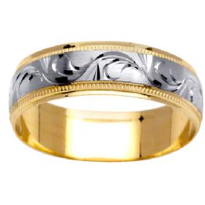
2 | Wedding ring | 14K Two Tone Gold | 6-12 g | 6.5 mm | Satin | 5 - 13 available | Two yellow gold ridges wrap around the white gold band creating a yellow gold accent that's subtle. | 350 | 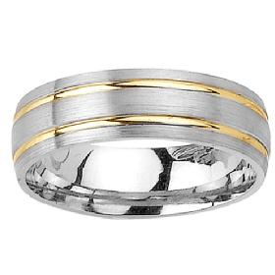
3 | Engagement ring | 3 Stone 14k White Gold | 6.00 g |  | Polished | 4 - 9 available | Center Diamond  - Round Diamond  - 0.40 ct  - SI Clarity, G-H Color  - Prong Setting  Side Diamonds  - Round Side Diamonds  - 0.33 ctw Eng. Ring, 2 Diamonds  - SI Clarity, G-H Color  - Prong Setting | 1 100 | 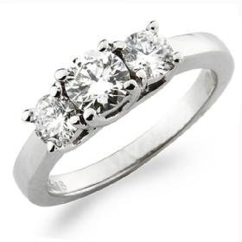
4
5
6
7
8
9
10
11
12
13
14
15
16
17
18
19
20
21
22
23
24
25
26
27
28
29
30
31
32
33
34
35
36
37
38
39
40
41
42
43
44
45
46
47
48
49
50
51
52
53
54
55
56
57
58
59
60

